TASK 1

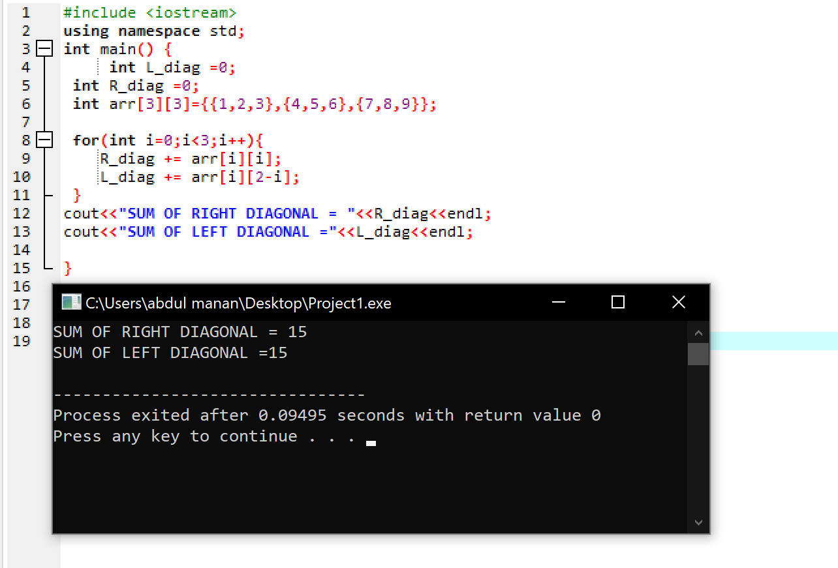

TASK 2

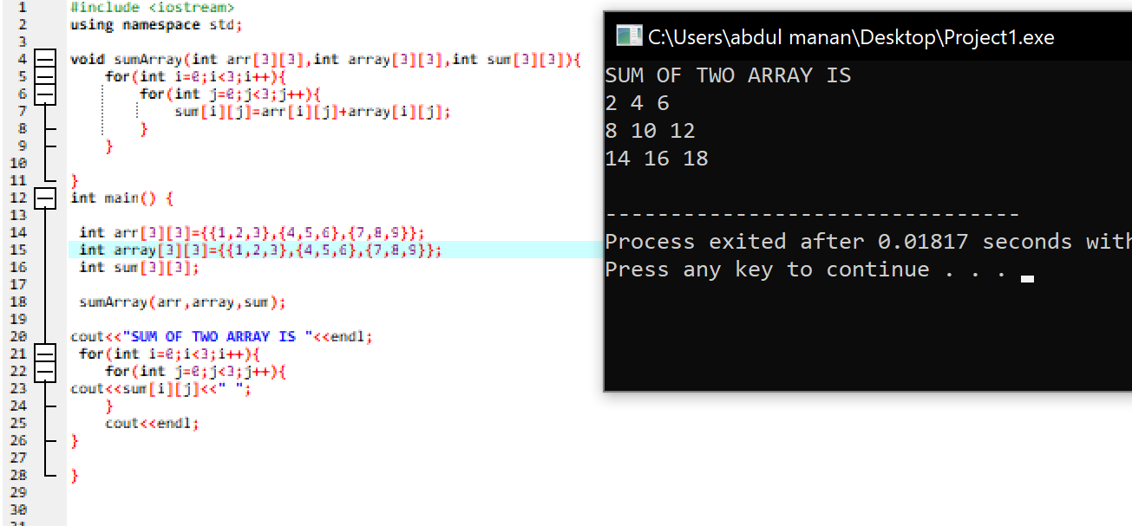

TASK 3

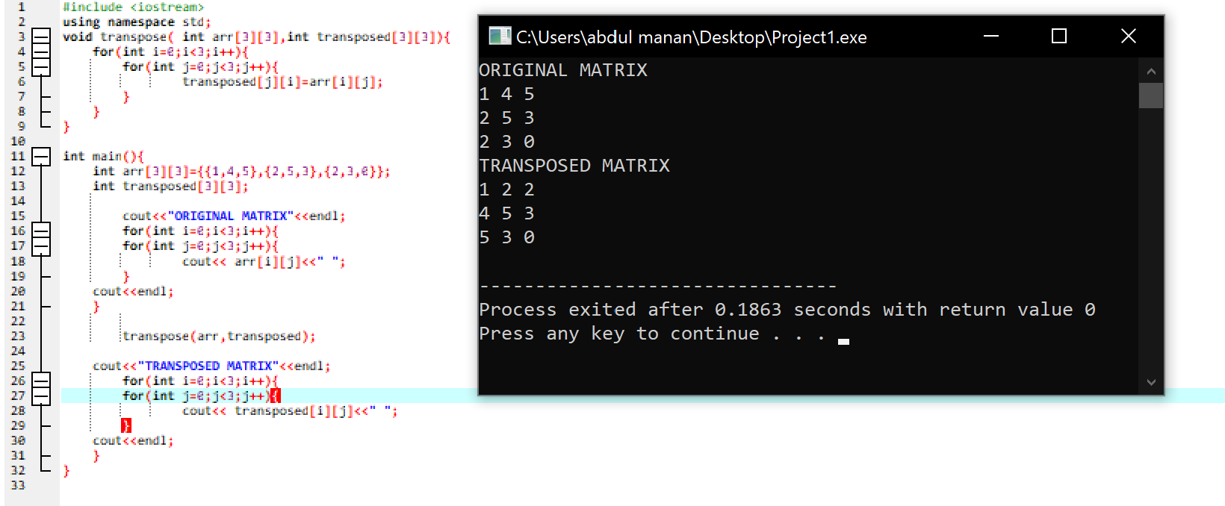

TASK 4

TASK 5

